Novice Observer’s Challenge:

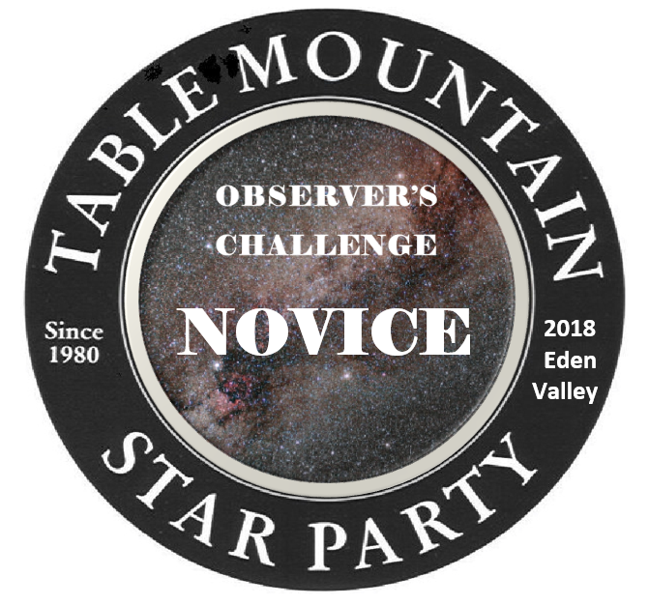
If you came to the Table Mountain Star Party (TMSP) with your spouse, significant other or parents and have never shown a great interest in astronomy, this program is for you. It will give you just a taste of what they do when they spend all those nights outside looking at the sky. It’s easy, will broaden your knowledge of the night sky and you’ll get a button for finding just 10 of the naked eye objects on the list. All observations must be done during the TMSP.
You must find the objects yourself, without help from anyone else. You may ask someone to help you orient the star chart and point you in the direction of north. Check off each object in the space provided. To receive your button, turn in you observations to Mark Simonson or Ron Mosher (Observation Challenge Coordinators) any time during the TMSP. If you finish the list the last night of TMSP, and we are not available to get you your button, just mail your observations to me at 1519 Ridge Dr., Camano Island, WA. 98282, or email your observations to me at marknilse@yahoo.com, and I will see that you get a button. The Novice Observer’s Challenge can only be earned once per person.

THE LIST

Observer’s Name:_____________________

____ 1. The Big Dipper – in the constellation Ursa Major. Seven bright stars that make up a dipper
pattern. Date:________ Time:_________

____ 2. Mizar and Alcor. The second star from the end of the handle of the Big Dipper is actually a
double star. You must see the two stars. Date:________ Time:_________

____ 3. Polaris, the North Star – Use the two stars that form the outer side of the cup of the Big
Dipper as pointers. Start with the star at the bottom of the cup, go to the star at the top of
the cup and continue the line about 5 times the distance between those two stars to the
brightest star in the area. Date:________ Time:_________

____ 4. Arcturus – the brightest star in Bootes. To find it, follow the curve of the stars in the handle
of the Big Dipper downward and to the right. This will bring you to a reddish yellow star,
Arcturus. Date:________ Time:_________

____ 5. The Milky Way - a faint, whitish glow, stretching in a huge arc from the southern to
northeastern horizon. It has a mottled effect, kind of like a fluffy cloud. There are brighter
areas, especially down toward the core of the galaxy in the southern part of the sky. There
are also darker patches, where nearby clouds of interstellar dust block the light from beyond.
Date:________ Time:_________

____ 6. The Dark Rift - You’re looking for dark lanes of dust, running the length of the starlit Milky
Way band. Date:________ Time:_________

____ 7. The constellation Cassiopeia. A large “W” or “M” shape. Date:________ Time:_________

____ 8. The planet Mars. Date:________ Time:_________

____ 9. The planet Saturn. Date:________ Time:_________

____ 10. The planet Jupiter. Date:________ Time:_________

____ 11. An International Space Station (ISS) flyover. Date:________ Time:_________

____ 12. The Andromeda Galaxy. Date:________ Time:_________

____ 13. The Double Cluster. Date:________ Time:_________

____ 14. The constellation Sagittarius. The Teapot. Date:________ Time:_________

____ 15. The constellation Lyra. The Harp. Date:________ Time:_________

____ 16. The constellation Corona Borealis – a group of 7 stars that resemble a crown.
Date:________ Time:_________

____ 17. The constellation Hercules. The Keystone asterism. Date:________ Time:_________

____ 18. M-13 – A bright globular cluster in Hercules. Looks like a small fuzzy patch.
Date:________ Time:_________

____ 19. The Summer Triangle – the stars Altair, Deneb and Vega are the brightest stars in the three
constellations Aquila, Cygnus and Lyra, respectively and make the Summer Triangle.
Date:________ Time:_________

____ 20. Locate the Northern Cross – in the constellation Cygnus. Date:________ Time:_________

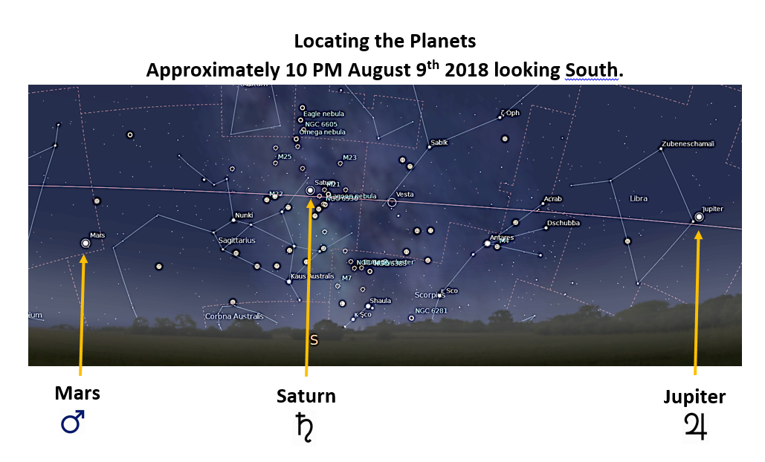
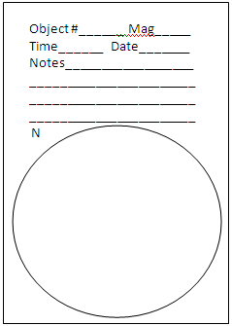

.

.

.

The Summer Sky
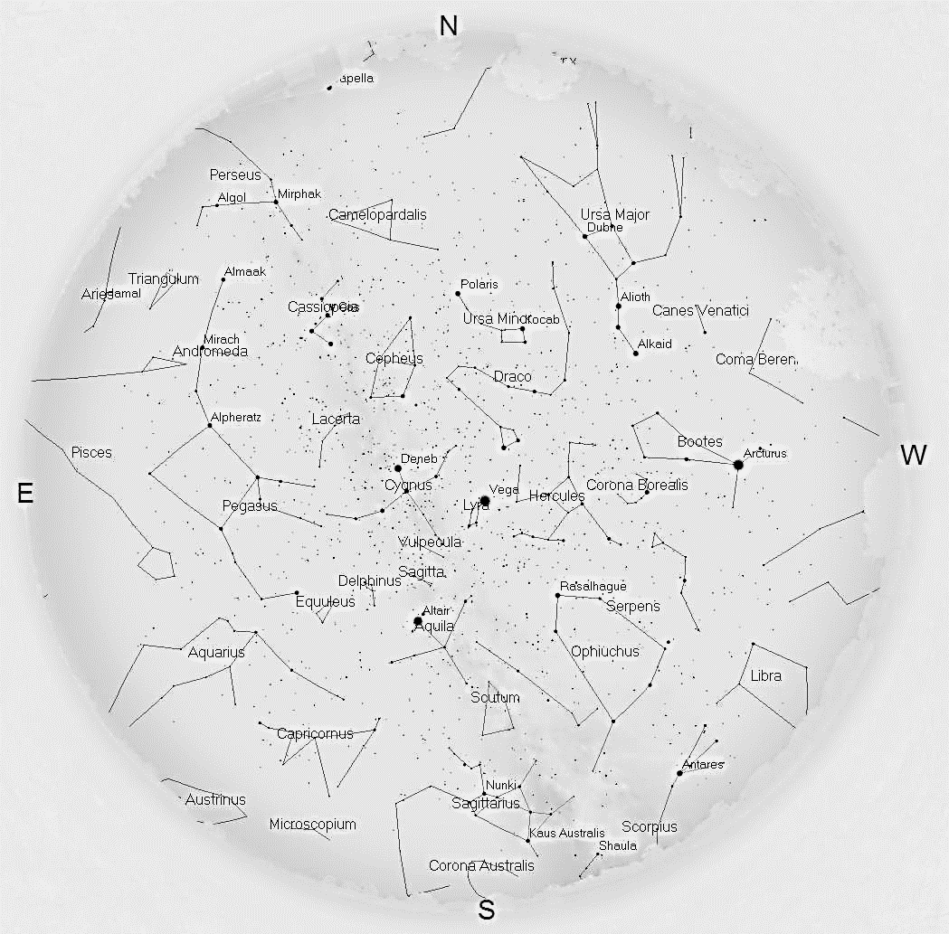

The Summer Sky
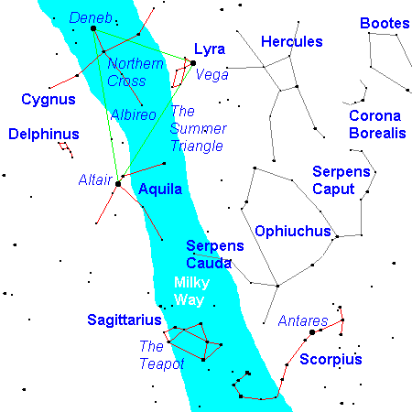
The spectacular summer sky has few really bright stars but picturesque constellations galore and a glorious view of the Milky Way.
The Summer Triangle consists of Deneb and Vega, almost circumpolar for the northern U.S., and Altair. Light from Altair left 16 years ago. Light from Vega left 27 years ago. Light from Deneb left before the Roman Empire fell. Deneb is the brightest star of Cygnus, the Swan, and forms its tail (Deneb means "tail" in Arabic). The Swan is flying with its outstretched neck, and the shape really reflects the constellation name. The head of the Swan, Albireo, is one of the most beautiful double stars in the sky as seen through a small telescope. If you omit the wingtips, the rest of Cygnus forms a cross called the Northern Cross.
Vega is the brightest star in Lyra, a small parallelogram capped by an equilateral triangle. Altair is the brightest star in Aquila, the Eagle, another constellation that's not a bad match for its name, though not terribly bright. Between Aquila and Cygnus is tiny Delphinus, the Dolphin, not very brilliant but very attractive and really fitting its name.
Skimming the southern horizon is Sagittarius, whose stars outline a teapot, and Scorpius the Scorpion, yet another constellation that looks like its namesake. Scorpius is dominated by reddish Antares, whose name means "anti-Mars" because it looks similar to that planet. Between Scorpius and Hercules is faint, sprawling Ophiuchus and the two halves of Serpens. Because of how constellation boundaries are drawn, the Sun actually spends more time in Ophiuchus than it does in Scorpius, and every so often the astrology community gets excited at the "discovery" of a thirteenth constellation in the Zodiac.
Two important points are not marked on the chart. Between Vega and Hercules is the direction the Sun is moving relative to nearby stars. Just off the spout of the teapot of Sagittarius is the center of the Milky Way Galaxy, invisible to the eyes but detectable in radio waves.

Greek Mythology (The Story of Cassiopeia)
Cassiopeia was very proud of her beauty. She claimed that she and her daughter Andromeda were more beautiful than the sea-nymphs, the Nereids.
The nymphs complained to the sea god Poseidon, who threatened to send a sea monster and flood to destroy Cassiopeia's land. This monster is commemorated in the constellation Cetus. In despair, the king Cepheus consulted an oracle to prevent the destruction of his reign. The oracle predicted that only the sacrifice of Andromeda to the monster could appease the wrath of Poseidon.
The king chained Andromeda to a sea cliff. Fortunately, at this same moment, Perseus, the nephew of the king of Argos, was traveling along the coast. Perseus noticed the beautiful woman and fell in love with her. Learning of Andromeda's story, he offered to rescue her if her parents agreed to let him marry their daughter. With the help of some magical sandals that allowed Perseus to fly, and a magical sword given to him by the god Hermes, Perseus killed the monster
According to a Greek legend, the sea god Poseidon placed the figure of Cassiopeia among the stars. It is said that Cassiopeia has a ridiculous upside-down position to punish her for having been pretentious. Cassiopeia is depicted sitting on her throne. Each night she circles the celestial pole, sometimes upright, sometimes hanging upside down in apparent danger of falling out. The mythologists interpreted the indignity of this celestial fairground ride as part of her punishment from the gods, who made her a figure of fun. Aratus wrote that she plunged headlong into the sea like a diver (some translate it as ‘tumbler’), her feet waving in the air, because as seen from Greek latitudes she would have received a ducking at the lowest point on each circuit. Her long-suffering husband Cepheus alongside her endured the same fate.

