Binocular Observer’s Challenge:

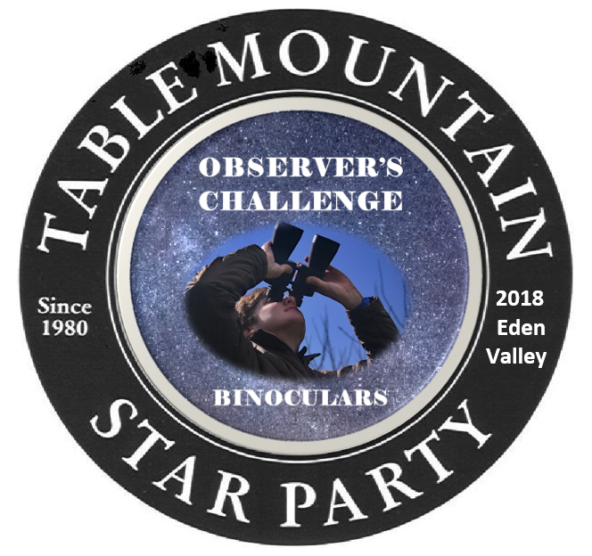
If you came to the Table Mountain Star Party (TMSP) with your binoculars or have access to binoculars while at the TMSP this program is for you. This program will give you an opportunity to observe 30 or more showcase objects under the ideal conditions of the pristine Eden Valley skies. It’s not super challenging this year, but will get progressively harder each year. You will get a button for finding just 25 of the objects on the list. All observations must be done during the TMSP.
You must find the objects yourself, without help from anyone else. Check off each object in the space provided. Enter required information and for at least three of the objects you must sketch what you see through your binoculars.
Any size binoculars can be used. All objects are within range of small to medium sized binoculars, and are available for observation between 10:00PM and 4:00AM any time during the TMSP. All objects are listed in Right Ascension order so that you can observe them before they set in the West, or as they rise in the East.
To receive your button, turn in your observations to Mark Simonson or Ron Mosher (Observation Challenge Coordinators) any time during the TMSP. If you finish the list the last night of TMSP, and we are not available to give you your button, just mail your observations to me at 1519 Ridge Dr., Camano Island, WA. 98282, or email your observations to me at marknilse@yahoo.com, and I will see that you get a button.

THE LIST

Observer’s Name:___________________ Binoculars______________

Open Cluster – OpCl Globular Cluster – GbCl Galaxy – Gal Double Star – Dbl Planet – Pla Light Year - Ly
Planetary Nebula – PNeb Emission Nebula - ENeb Reflection Nebula – RNeb Dark Nebula – DNeb

# Object Type R.A. Dec Con Size Mag Notes
B1 | NGC 224 M31 | Gal | 00 42.3 | +41 16 | And | 192.4 | 3.4 | The Andromeda Galaxy Spiral 2.5 million Ly
B2 | NGC 598 M33 | Gal | 01 33.5 | +30 39 | Tri | 70.0 | 5.7 | The Triangulum Galaxy Spiral 3 million Ly
B3 | NGC 869/884 Double Cl | OpCl | 02 19.0 | +57 08 | Per | 29.0 | 5.3 | The Double Cluster also Caldwell 14 7500 Ly
B4 | NGC 3031 M81 | Gal | 09 55.3 | +69 03 | UMa | 26.9 | 6.9 | Bode’s Galaxy Spiral 12 million Ly
B5 | NGC 3034 M82 | Gal | 09 55.8 | +69 41 | UMa | 9.0 | 8.4 | An irregular galaxy very close to M81 12 million Ly
B6 | Mel 111 Coma Cluster | OpCl | 12 25.0 | +26 00 | Com | 275.0 | 1.8 | The Coma Star Cluster about 40 bright stars 280 Ly
B7 | NGC 5272 M3 | GbCl | 13 42.2 | +28 23 | CVn | 16.0 | 5.9 | 1 of approx. 150 GbCl orbiting Milky way 3400 Ly
B8 | Jupiter | Pla | 14 47.4 | -15 10 | Lib | 37.0 | -2 | Can you see the 4 Galilean Moons? 483.6 million miles
B9 | NGC 5904 M5 | GbCl | 15 18.6 | +02 05 | SerCp | 17.0 | 5.7 | A Globular Cluster 24500 Ly
B10 | NGC 6205 M13 | GbCl | 16 41.7 | +36 28 | Her | 17.0 | 5.7 | The best GbCl northern hemisphere 22200 Ly
B11 | NGC 6229 | GbCl | 16 47.0 | +47 32 | Her | 4.5 | 9.4 | Another GbCl in Hercules 10000 Ly
B12 | NGC 6218 M12 | GbCl | 16 47.2 | -01 57 | Oph | 15.0 | 6.8 | GbCl 15700 Ly
B13 | NGC 6254 M10 | GbCl | 16 57.1 | -04 06 | Oph | 15.0 | 6.6 | GbCl 14300 Ly
B14 | NGC 6341 M92 | GbCl | 17 17.1 | +43 08 | Her | 11.0 | 6.4 | GbCl 26700 Ly
B15 | IC 4665 | OpCl | 17 46.3 | +05 43 | Oph | 70.0 | 4.2 | OpCl 1400 Ly
B16 | NGC 6523 M8 | ENeb | 18 03.3 | -24 23 | Sag | 90 | 6.0 | The Lagoon Nebula 4100 Ly
B17 | Saturn | Pla | 18 13.1 | -22 37 | Sgr | 42 | 1.1 | Can you see the rings? Titan? 855.6 million miles
B18 | NGC 7789 | OpCl | 18 27.7 | +06 34 | Oph | 27.0 | 4.6 | OpCl also Caroline’s Rose 7600 Ly
B19 | NGC 5720 M57 | PNeb | 18 53.3 | +33 01 | Lyr | 86.0 | 8.8 | PNeb also Ring Nebula 2300 Ly
B20 | Cr399 Coathanger | OpCl | 19 25.4 | +20 11 | Vul | 60.0 | 3.6 | Asterism known also known as Brocchi’s Cluster
B21 | Albireo | Dbl | 19 30.4 | +27 57 | Cyg | - | 5.0 | Beautiful one amber and the other blue/green 430 Ly
B22 | NGC 6826 | PNeb | 19 45.0 | +50 34 | Cyg | 126.0 | 8.8 | The “Blinking Planetary” also Caldwell 15, 2000 Ly
B23 | NGC 6853 M27 | PNeb | 19 59.6 | +22 43 | Vul | 8.0 | 7.3 | The Dumbbell Nebula 1360 Ly
B24 | Mars | Pla | 20 20.1 | -26 17 | Cap | 24 | -2 | Can you make out any features? 35.3 million miles
B25 | NGC 6913 M29 | OpCl | 20 23.9 | +38 32 | Cyg | 6.0 | 6.6 | OpCl 6000 Ly
B26 | NGC 6960 Veil West | ENeb | 20 45.4 | +30 43 | Cyg | 70.0 | 7.0 | The west part of a supernova remnant 1470 Ly
B27 | LDN 935 | DNeb | 20 56.4 | +43 52 | Cyg | 90 | - | Wide dark lane separating NGC 7000 and IC 5070
B28 | NGC 7000 | ENeb | 20 59.1 | +44 31 | Cyg | 120 | 4.0 | The North American Nebula 1600 Ly
B29 | NGC 7078 M15 | GbCl | 21 30.0 | +12 10 | Peg | 12.0 | 6.0 | GbCl 33600 Ly
B30 | NGC 7092 M39 | OpCl | 21 32.2 | +48 26 | Cyg | 31.0 | 4.6 | OpCl 824 Ly




